Ashley,

Unlike V0.0, Version 1.0 runs and outputs a pre-defined output from London. Which is a step in the right direction.

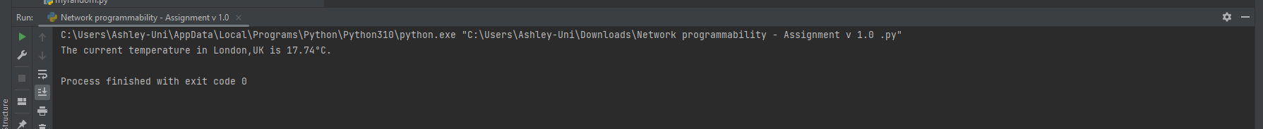

Feedback

* Would be nice to have a manual input instead of London.
* Would be nice to have some form of GUI to make it look more like a working application.